|  |  |  |
| --- | --- | --- |
| SCHOOL OF INFORMATION TECHNOLOGY | | |
| NAME: Richmond_Al P. Broqueza | |  |
| SECTION:IDB2 | DATE SUBMITTED:12/06/24 |

# <SUBJECT CODE> PORTFOLIO

**Table of Contents**

|  |  |  |
| --- | --- | --- |
| **Name of Activities** | **Date of Activity** | **Page No.** |
| **First Grading** | | |
| Quizzes | | |
| Quiz 1 | 08/21 | 3 |
| Quiz 2 | 09/11 | 3 |
| Other Activities | | |
| Assignment Commands Simulation | 08/30 | 3 |
| First Grading Exam - Lecture | 09/20 | 4 |
| First Grading Exam – Lab | 09/16 | 4 |
| **Midterms** | | |
| Quizzes | | |
| Quiz 1 | 10/9 | 5 |
| Quiz 2 | 10/11 | 5 |
| Quiz 3 | 10/16 | 5 |
| Quiz 4 | 10/18 | 6 |
| Quiz 5 | 10/23 | 6 |
| Midterm Exam | 10/28 | 7 |
| **Finals** | | |
| Quizzes | | |
| Quiz 1 | 11/13 | 8 |
| Quiz 2 | 11/29 | 8 |
| Final Exam |  |  |
| Course Reflection |  |  |

**First Grading**

**Quiz 1: Quiz:2**

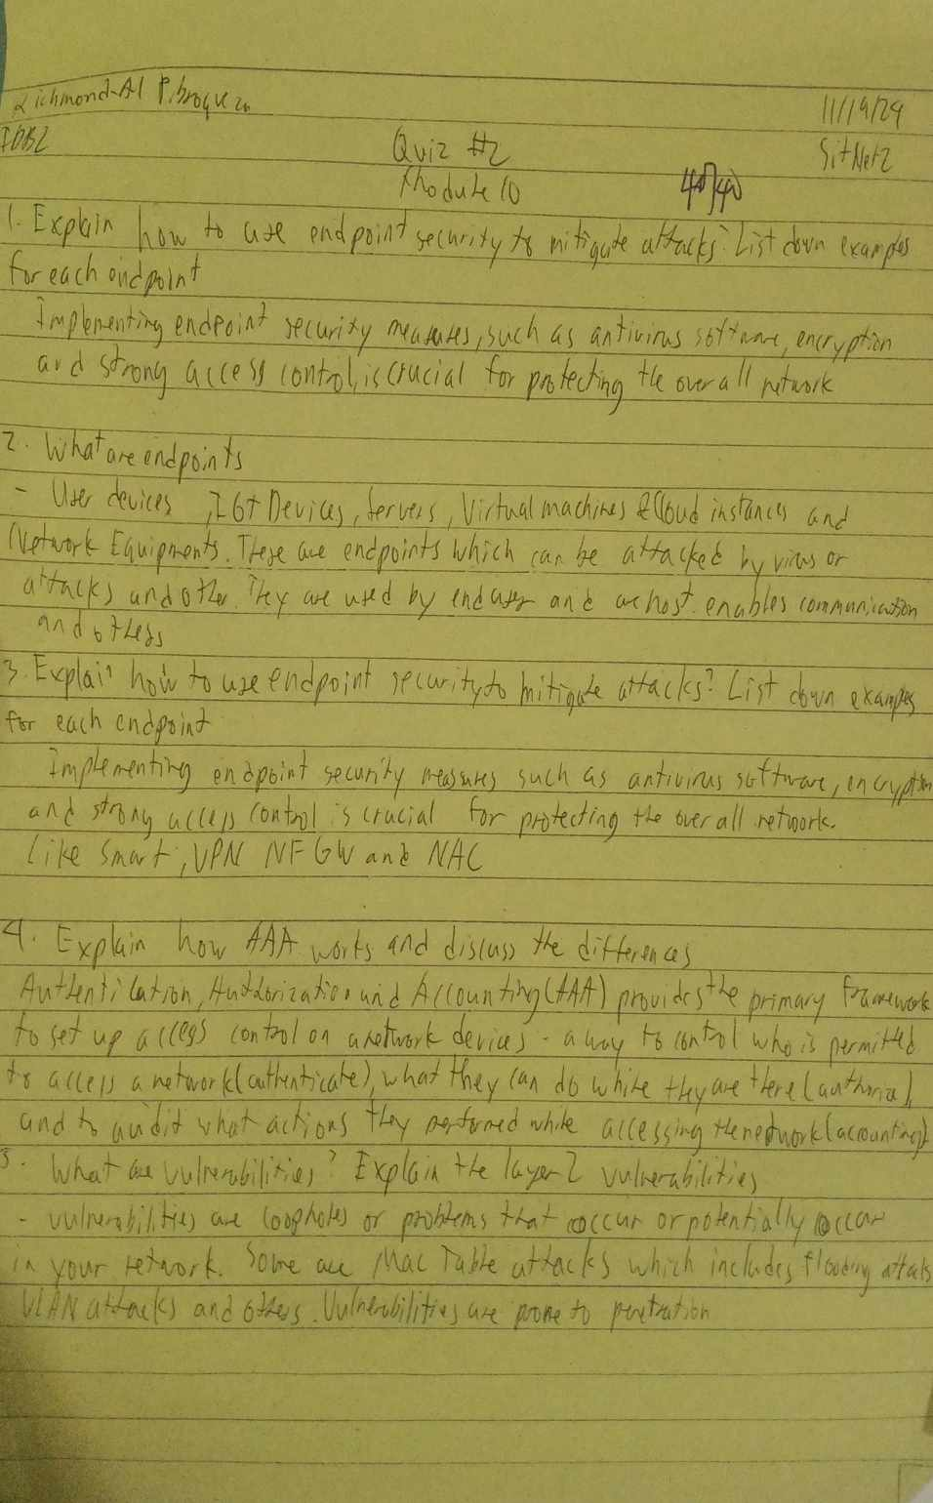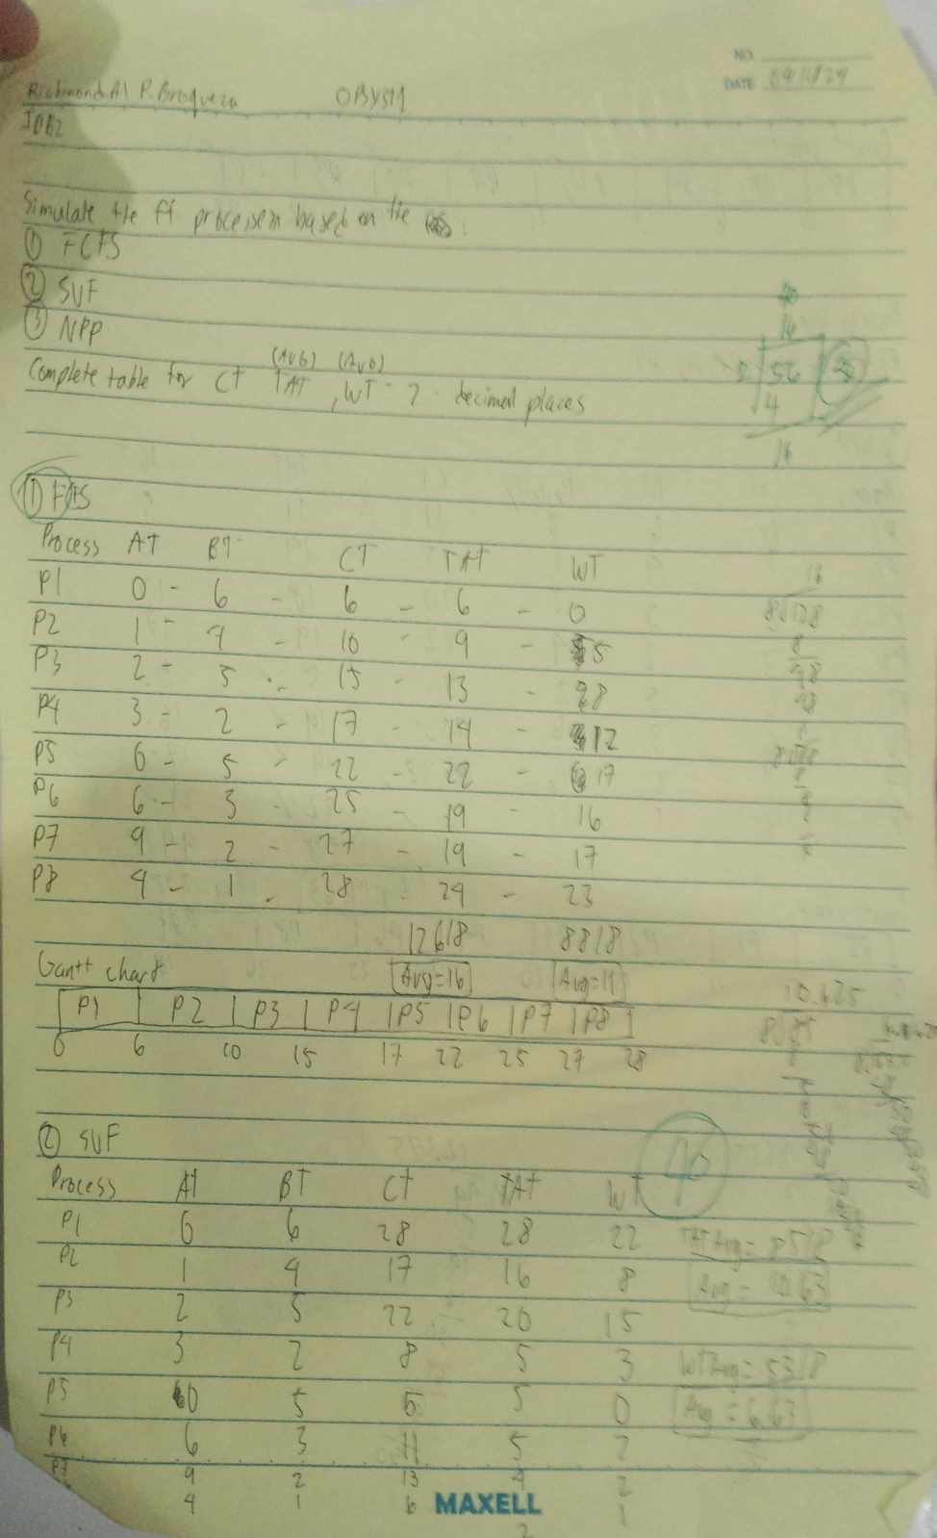

**Assignmet:**

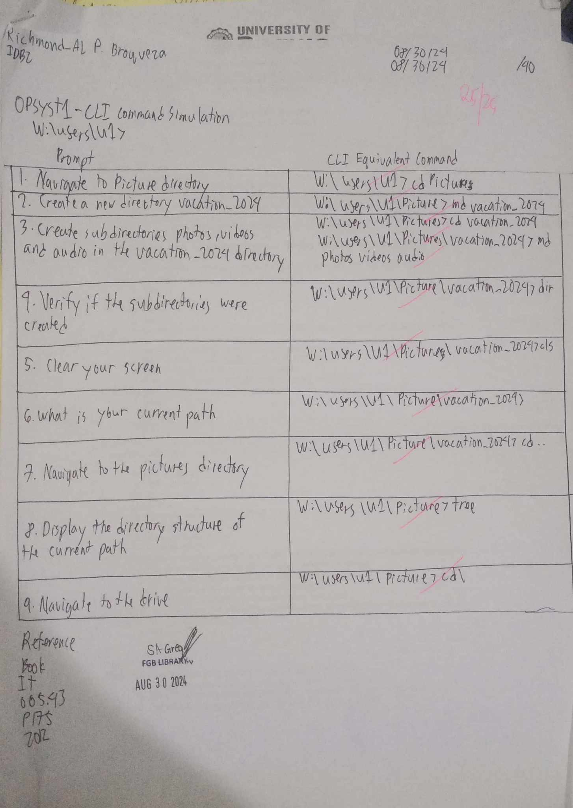

**First Grading Exam-Lecture:**

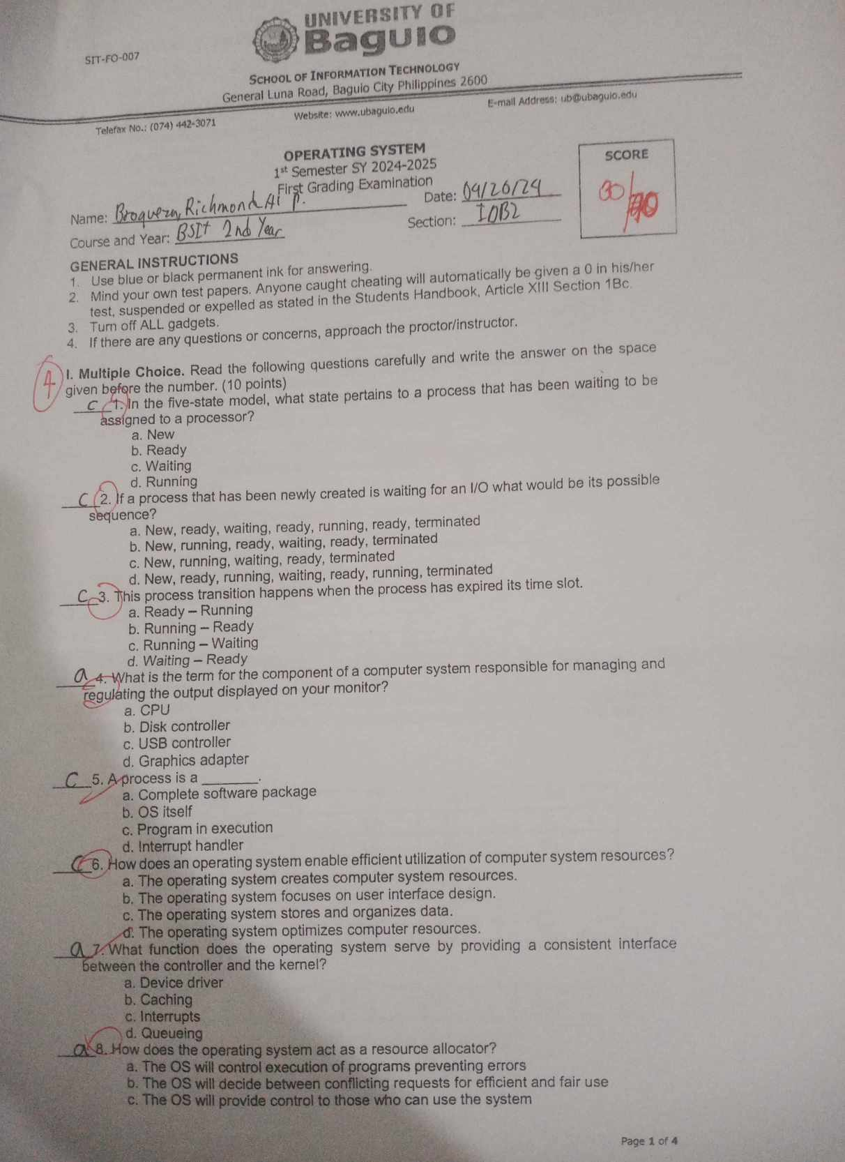

**First- Grading Exam- Laboratory**

**Midterm**

**Quiz 1: Quiz 2:**

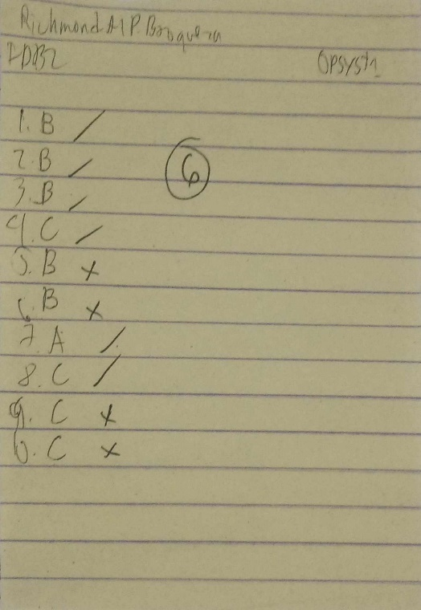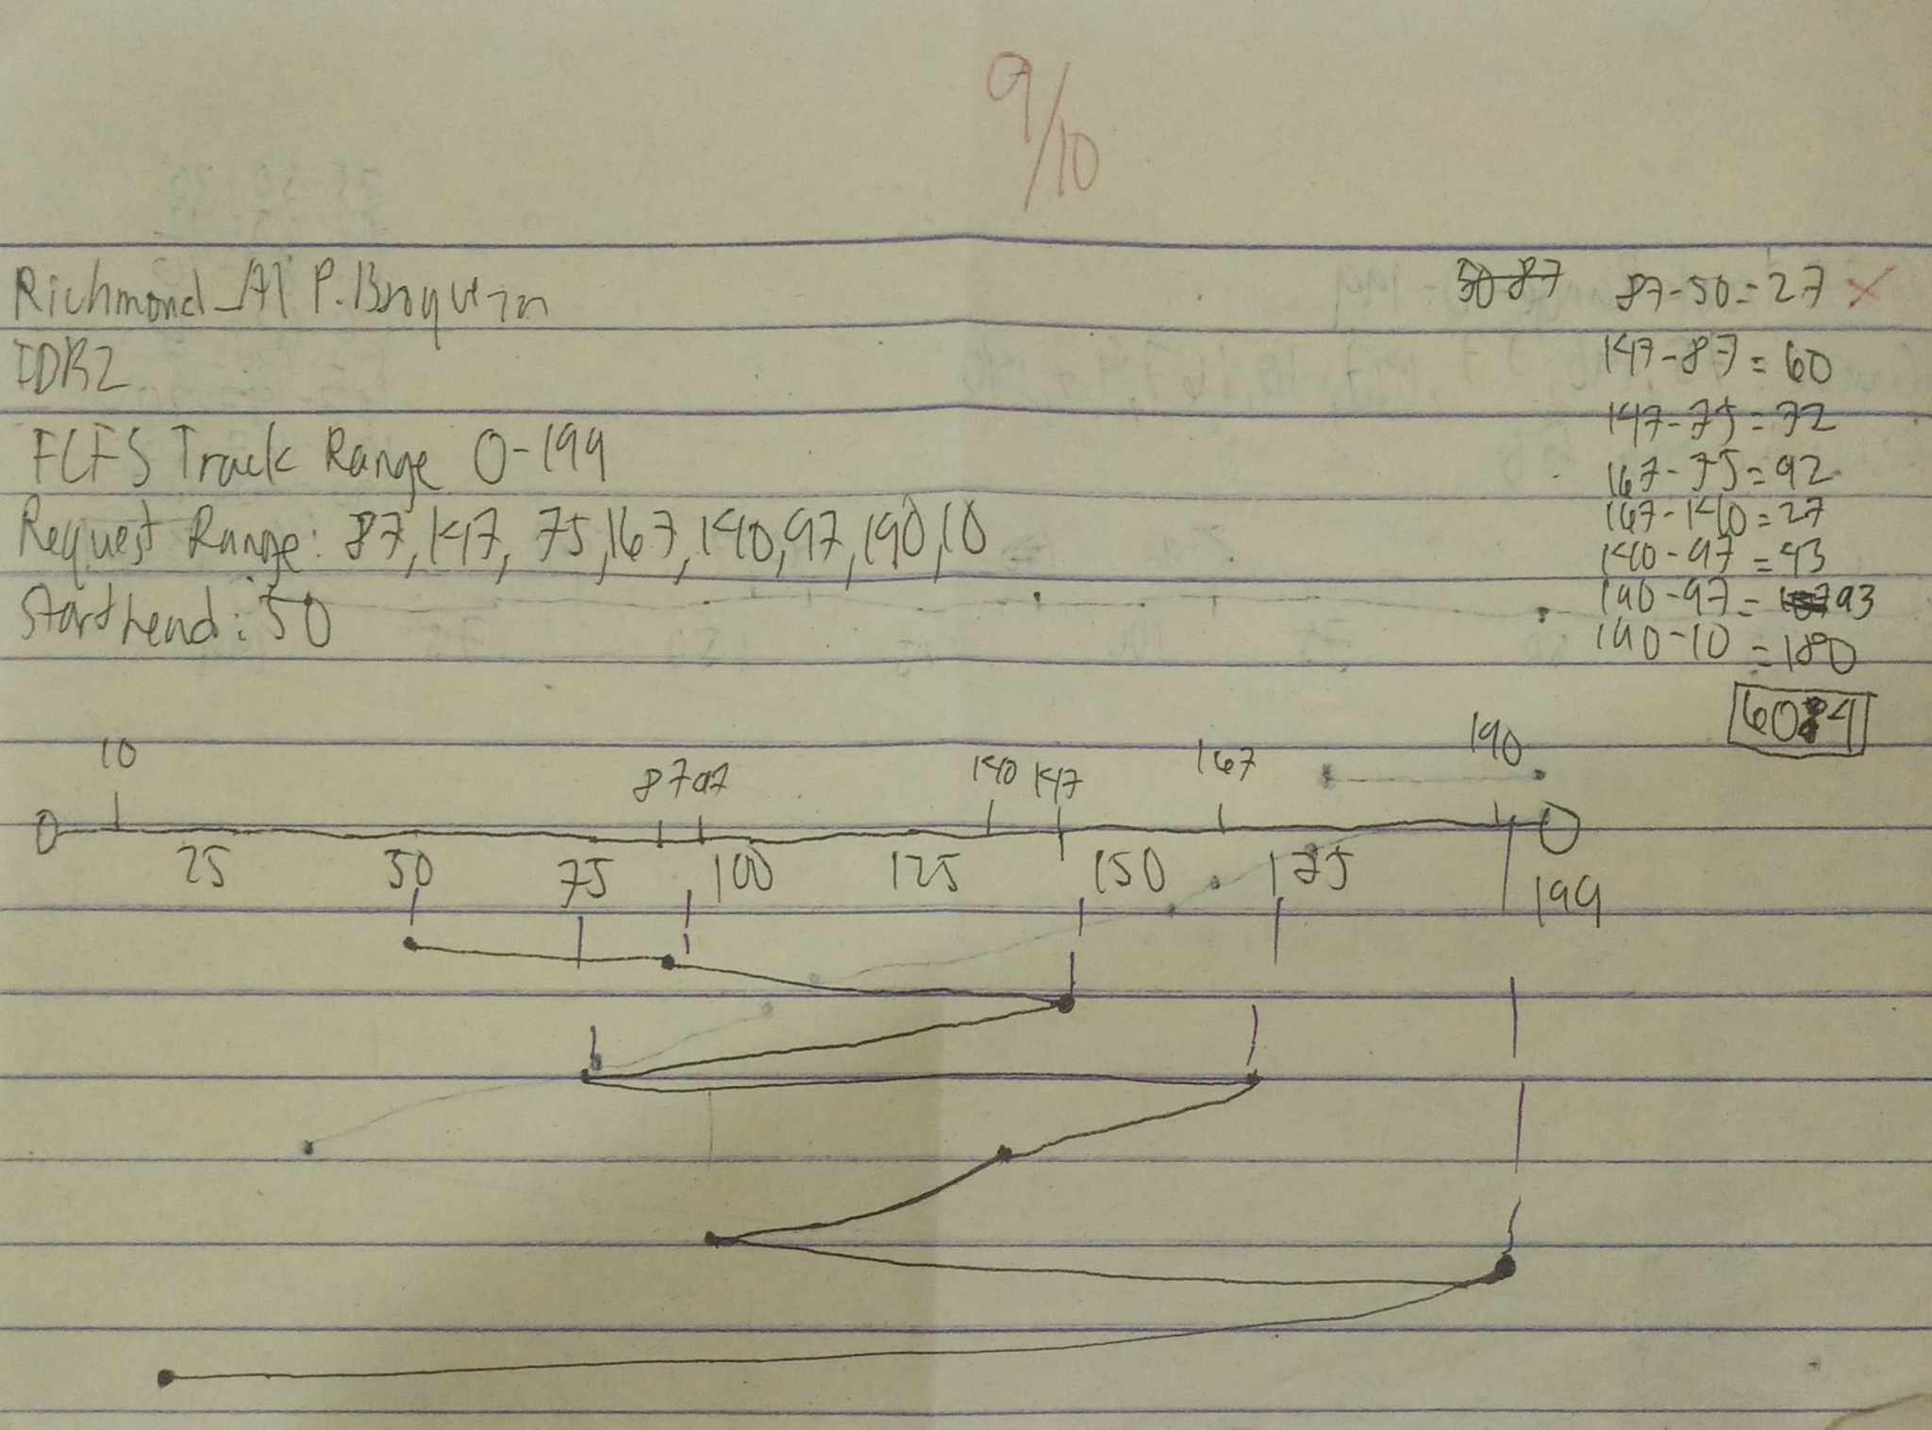

**Quiz 3:**



**Quiz 4: Quiz 5:**

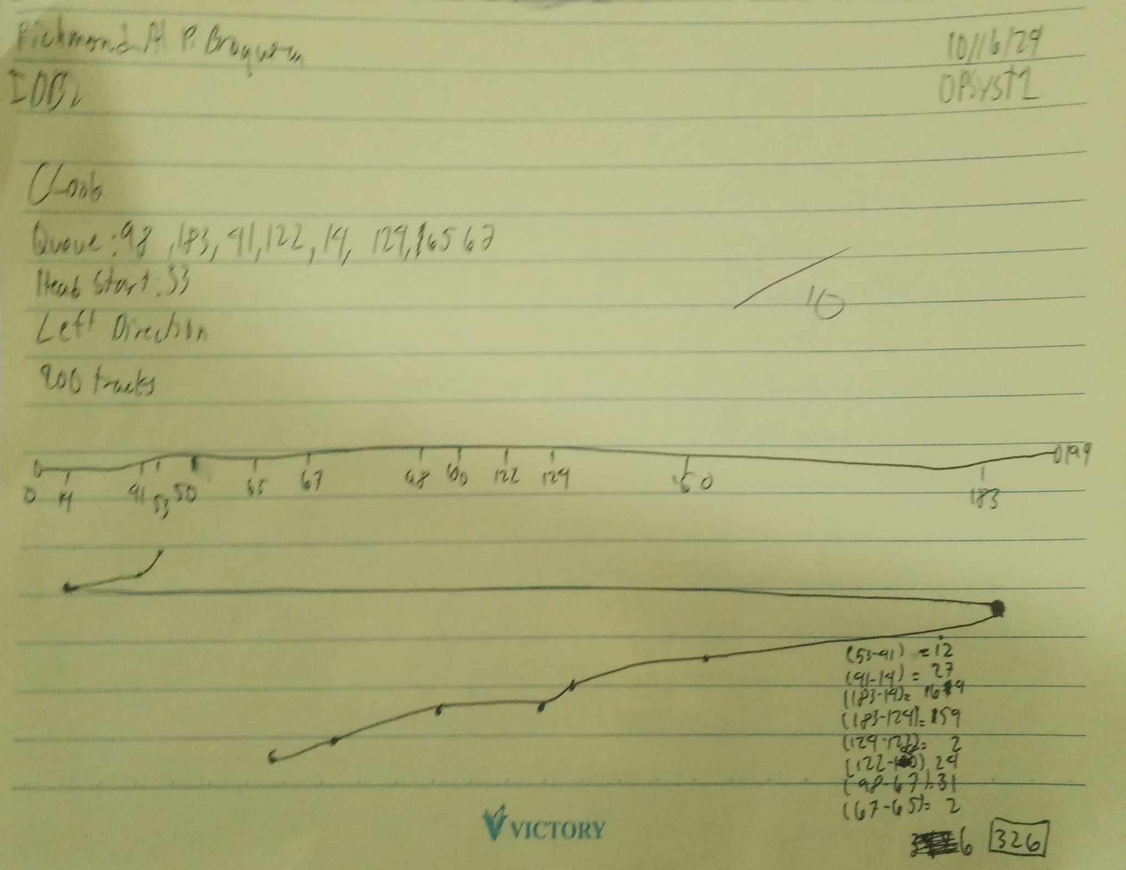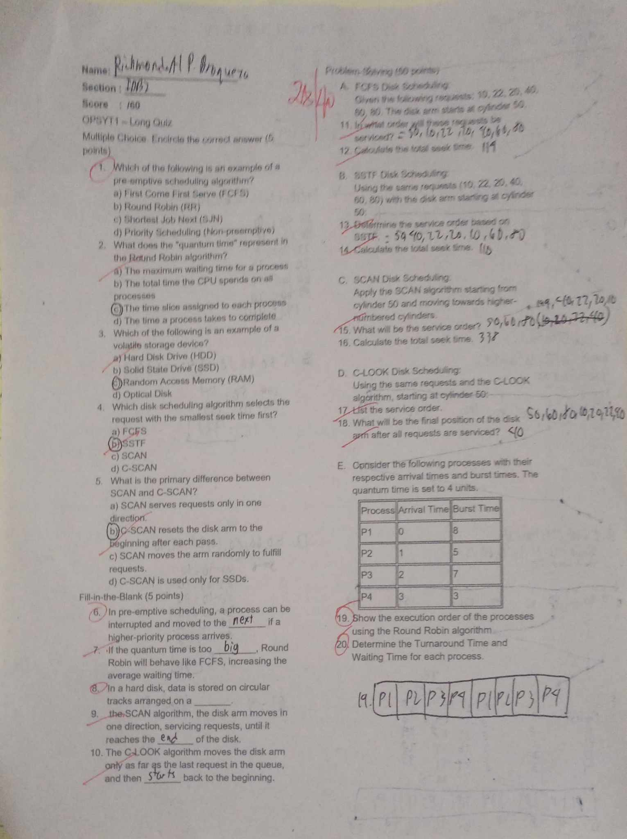

**Midterm Grading Exam:**

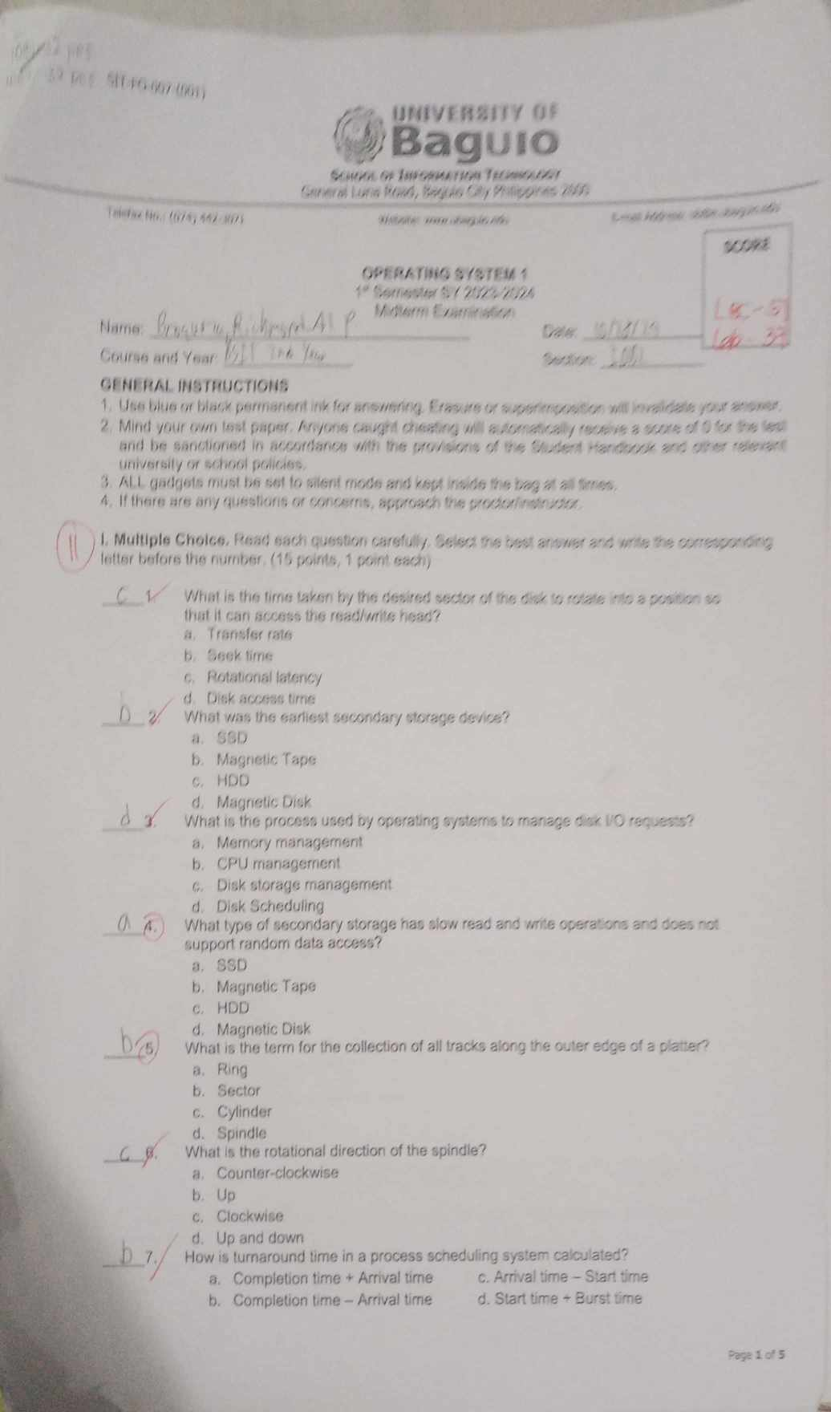

**Finals**

**Quiz 1: Quiz 2:** 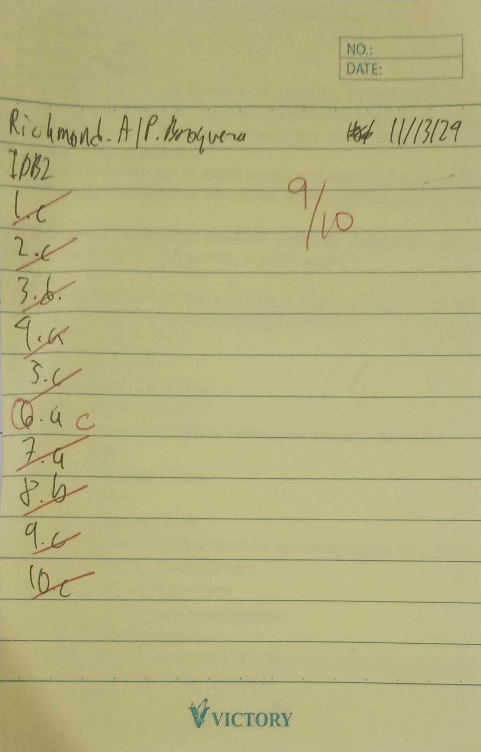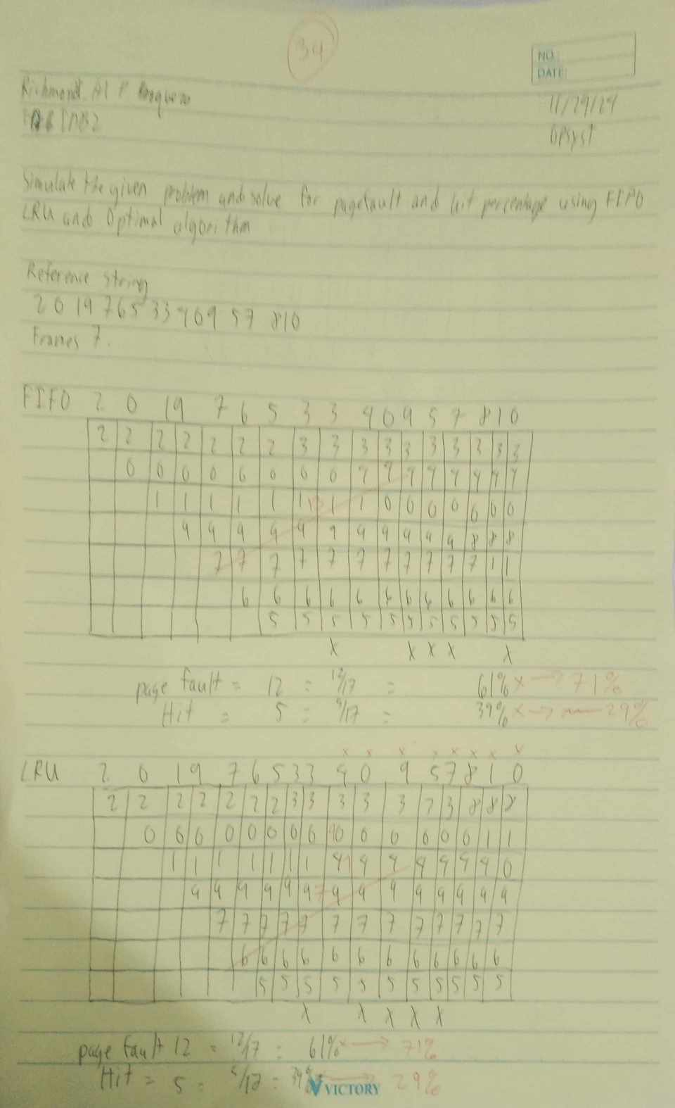

**Course Reflection**

What were your initial expectations for the course? Did the course meet, exceed, or fall short of these expectations?

|  |
| --- |
| The course has shown me some of the interesting things and satisfy my curiosity among things in the apsects of technology and some things questioning how they do. The course meets my expectations and the initial expectations is that I’m hoping to learn a lot and others. |

What were the main topics or concepts covered in the course? How did these topics contribute to your understanding of the subject matter?

|  |
| --- |
| The topics that were covered in the main course are a few about memory allocation, digital disk fragmentation and virtual memory and these contributes to my pursuit of knowledge and could help for my future career job. |

Reflecting on your learning process, what were the most effective strategies or techniques that helped you grasp and retain the course material?

|  |
| --- |
| The strategies or techniques that help is nothing special, just listening and understanding the materials and others. Listening especially to the laboratory parts is important as well as how you understand it. |

Were there any particular assignments, projects, or activities that significantly enhanced your learning experience? Why were they effective?

|  |
| --- |
| Most of the assigments and activities have significantly enhanced my learning experience by experiencing them and contributing to my pursuit and there are effective because these stimulates my mind as to how to obtain these knowledge, how is my understanding of those activities and others. |

Did you encounter any challenges or difficulties during the course? How did you overcome these obstacles, and what did you learn from them?

|  |
| --- |
| There are some challenges and difficulties during the course and I was able to overcome them as to thinking more creatively and more on outside of the box and also learning advice and tips from others. |

Did the course encourage critical thinking and analysis? How did it promote higher-order thinking skills, such as problem-solving or decision-making?

|  |
| --- |
| It did encourage and promote on my critical thinking and analysis by exercising my mind and having more of a broader concept among things and making me see it in a different perspective. |

Reflecting on your personal growth, what new knowledge, skills, or perspectives did you gain from this course?

|  |
| --- |
| The server settings, policy and others, how to technology mostly memory is functioning and most operating system and others. |

How do you plan to apply what you have learned in this course to your future studies, career, or personal life?

|  |
| --- |
| These are topics that I can apply in my future studies , career and personal life as my course is mostly about technology and networking as these things are essential as these will be useful in my career and troubleshooting most devices. |